Introduction
Online (Web-based) Shopping is an effective solution for brought things in Shopping center. This project entitled Online Fuel service is a complete solution for those who are habituated to technology. Various modules together form the entire project.
This project handles the details about the customers who can purchase the product, payment details against the buying products, available product details on online shopping process.
All of the above processes are controlled by a login form in order to protect information about the bidding performed by the customer. So a customer must create an own account before processing starts. The Admin the facility to enter the category want to precede the shopping process on online.
Buyer account creation can be made on their own. Product Handling and Category Formation, Payment and Acknowledgement are also indulged.
Modules

- Buyer Registration
- Buyer Login
- E-Shopping procedure
- Categories of Goods
- Secured Payment System
- PayPal Account

Problem Definition

In Shopping, we should do the various kinds of manual and transportation work. Customer also came to bring the things from various places. It is very tedious one. In each Shopping, we have destroyed more than 1000 trees. After the Shopping, Customers and analyst want to analyze the result. Without online Shopping, it should be very difficult to follow up.

Objective of the Study
The main objective of our online Fuel Service, Customer can buy things like petrol , diesel ,speed petrol and various kinds of engine oils in the shopping center. All the exams are the open book exam.
In power failure or system failure, student can restart the exam from the last session. We have used the open source software only.

Existing System

In the existing system the customer has to reach the fuel station in order to purchase fuel. In times a customer has to travel in opposite direction of his destination to fuel his vehicle. Customer has to wait in the queue. A person has to carry his vehicle to fuel station if fuel is exhausted in his way , this takes a lot of effort and time.
Sometimes customer may not have any fuel at the start of journey, in this case he needs to take another vehicle with an empty bottle to get the fuel.

Proposed System

The modern computerized system is developed with the aim to overcome the drawbacks of existing system. The proposed system has got many advantages. People from different parts of the city can register very easily. Fuel is delivered to the exact location where needed.

The new system is more personalized. It is maze in such a manner that all the new users can understand all the options in it very easily. It is made in a quick and easy referential manner. Access to all important matters are not always locked and can be opened easily at the time of urgency.

The advantages of proposed system are that security is maintained in the new system. Securities for all important data are maintained confidentially. As it is easily understandable, user friendly and quick entries can be made in this system.

Requirement Specification
Hardware Requirements

- Intel Pentium III Processor 650MHz or above
- Minimum 64MB RAM
- 100MB free space in Hard Drive
- 1024 x 768, High Color 17 inch Monitor

Software Requirements

- Windows XP Operating System
- PHP5
- MySQL 5.0 or above
- Apache 2.0 or above
ORGANIZATIONAL PROFILE – www.logicsystems.org.in (08886201526)
ABOUT US
LOGIC SYSTEMS is a cohesive group of software engineering Company engaged in providing quality complete end-to-end IT/software solutions, systems development, software integration and interactive web based solutions. LOGIC SYSTEMS specializes pre-built solutions that clients rapidly customize thus delivering business intelligence right at the customers’ doorsteps.
The Company applies robust and optimal methodologies; state of art technologies with software engineering skills to domain knowledge in creating information technology based solutions of clients in the respective domains.
LOGIC SYSTEMS, specializing cost effective, yet time bound and high technology solutions, has several offshore IT-Service facilities located in India. These state-of-the-art offshore facilities are home to many software engineers drawn from the finest institutions. The traditional approach of building an internal IT team is time consuming and expensive For almost all clients embarking on IT projects for in house operations, such short-term assignments work well for non-recurring needs, meets project goals and allows regular staff to continue in the core business areas.
LOGIC SYSTEMS assembles teams of employees and consultants with the specific expertise required for a project, enabling them in building best breed of approaches, methods, models and tools. It can also help to augment in-house staff and infuse new technology and services into operations. With business strategists, consumer marketing gurus, architects, designers, and senior professional developers LOGIC SYSTEMS can surely provide an expert team to build the optimum solutions.
MISSION
Our mission is to offer cost-effective, superior quality and commercially viable services and solutions to our clients and partners by evolving into a significant global IT-solution provider. We shall adhere to strong internal value systems with integrity, fairness and the pursuit of excellence in all our activities. These principles will be visible in our interactions with our clients, partners, associates and employees.
QUALITY FOCUS
We are engineers, designers and business people. We work hard, work smart and enjoy helping our customers succeed in this hi-tech marketplace. We believe in the principle: "Do it right, the First Time". Our new employees, too, learn this principle quickly, because we want to give our customers what they want, rather than what we think they should have. The quality effort is backed up by results. We aspire to be a global leader in IT services and part of this mindset is to be a complete IT-solutions and services provider. At LOGIC SYSTEMS, target is to set new benchmarks in productivity, customer satisfaction, employee satisfaction, and provide 'zero-defect' solutions. It is this urge to excel that drives us to search for new and better solutions that will support in every aspect of business strategy.
Why Us
Our Corporate Philosophy is
“Give a solution which is an amalgamation of expertise and the client’s needs”
We began with a vision of meeting the massive requirements for IT talent and services in a world moving into an information-based economy. We are a team of software professionals with experience in providing robust and optimally designed IT-Solutions. We have successfully executed projects in various industry segments and have a wealth of experience and expertise in project and resource management. By partnering with LOGIC SYSTEMS, you are dealing with an Indian Company with the Quality and Cost benefit advantages of an international corporation. Our objective is to anticipate and respond to the changing needs of our customers and fulfill their expectations better than our competitors.
We build lasting, high quality customer relationships in diverse domains - from e-commerce to corporate companies. We enhance the growth and profits of our clients by delivering effective and economical IT-Solutions on schedule.
BACKGROUND
It is without doubt, that growth of any nation is affected by information technology more than any other and also Indians have proved to be the best analytical minds world over. To maintain this status an urgent need is to keep pace with the state of art technologies and generate world-class professionals. The industry has been seized with the problem of shortage of computer professionals in various fields, while several individuals with high computer skill-set and analytical outlook are unable to be profitably employed. This is partly due to the non-standardized methodologies, models being learnt and used by these individuals. For the well informed and well trained, the availability of new technologies represents a real push for enhancing the quality in all departments improving the productivity and hence profitability. Considering the need of the hour LOGIC SYSTEMS has formulated a unique program for assisting thousands of such aspiring software professionals to prove their mettle and be a part of winning team.
SYSTEM STUDY
The primary goal of the system analyst is to improve the efficiency of the existing system. For that the study of specification of the requirements is very essential. For the development of the new system, a preliminary survey of the existing system will be conducted. Investigation done whether the upgradation of the system into an application program could solve the problems and eradicate the inefficiency of the existing system.
1 Feasibility Study:
The initial investigation points to the question whether the project is feasible. A feasibility is conducted to identify the best system that meets the all the requirements. This includes an identification description, an evaluation of the proposed systems and selection of the best system for the job. The requirements of the system are specified with a set of constraints such as system objectives and the description of the out puts. It is then duty of the analyst to evaluate the feasibility of the proposed system to generate the above results. Three key factors are to be considered during the feasibility study.
2 Operation Feasibility
An estimate should be made to determine how much effort and care will go into the developing of the system including the training to be given to the user. Usually, people are reluctant to changes that come in their progression. The computer initialization will certainly affected the turn over, transfer and employee job status. Hence an additional effort is to be made to train and educate the users on the new way of the system.

3 Technical Feasibility
The main consideration is to be given to the study of available resources of the organization where the software is to be implemented. Here the system analyst evaluates the technical merits of the system giving emphasis on the performance, reliability, maintainability.
By taking the consideration before developing the proposed system, the resources availability of the organization was studied. The organization was immense computer facilities equipped with sophisticated machines and the software hence this technically feasible.
4 Economic Feasibility
Economic feasibility is the most important and frequently used method for evaluating the effectiveness of the proposed system. It is very essential because the main goal of the proposed system is to have economically better result along with increased efficiency. Cost benefit analysis is usually performed for this purpose. It is the comparative study of the cost verses the benefit and savings that are expected from the proposed system. Since the organization is well equipped with the required hard ware, the project was found to be economically.

SYSTEM ANALYSIS
INTRODUCTION
After analyzing the requirements of the task to be performed, the next step is to analyze the problem and understand its context. The first activity in the phase is studying the existing system and other is to understand the requirements and domain of the new system. Both the activities are equally important, but the first activity serves as a basis of giving the functional specifications and then successful design of the proposed system. Understanding the properties and requirements of a new system is more difficult and requires creative thinking and understanding of existing running system is also difficult, improper understanding of present system can lead diversion from solution.
Analysis Model

The model that is basically being followed is the WATER FALL MODEL, which states that the phases are organized in a linear order. First of all the feasibility study is done. Once that part is over the requirement analysis and project planning begins. If system exists one and modification and addition of new module is needed, analysis of present system can be used as basic model.
The design starts after the requirement analysis is complete and the coding begins after the design is complete. Once the programming is completed, the testing is done. In this model the sequence of activities performed in a software development project are: -
- Requirement Analysis
- Project Planning
- System design
- Detail design
- Coding
- Unit testing
- System integration & testing

Here the linear ordering of these activities is critical. End of the phase and the output of one phase is the input of other phase. The output of each phase is to be consistent with the overall requirement of the system. Some of the qualities of spiral model are also incorporated like after the people concerned with the project review completion of each of the phase the work done.
WATER FALL MODEL was being chosen because all requirements were known beforehand and the objective of our software development is the computerization/automation of an already existing manual working system.
Product
Product

Input

Output

Process

Communicated Requirements

Requirements Specification

Design Specification

Executable Software Modules

Integrated Software Product

Delivered Software Product

Changed Requirements

Requirements Engineering
Design
Programming
Integration
Delivery
Maintenance

Requirement Specification
Hardware Requirements

- Intel Pentium III Processor 650MHz or above
- Minimum 64MB RAM
- 100MB free space in Hard Drive
- 1024 x 768, High Color 17 inch Monitor

Software Requirements

- Windows XP Operating System
- PHP5
- My SQL 5.0 or above
- Apache 2.0 or above

INPUT AND OUTPUT

The main inputs, outputs and major functions of the system are as follows

Inputs:
• Admin enters his or her user id and password.
• Users enter his or her user id and password.
• A user submits their details.
• Admin can edit the users’ details and so on.
• Users can search the monitoring details.

Outputs:
• Admin receives Users details and allot the duty of the users.
• A user receives the monitoring details and all other details.
PROCESS MODEL USED WITH JUSTIFICATION
The following commands specify access control identifiers and they are typically used to authorize and authenticate the user (command codes are shown in parentheses)
USER NAME (USER)
The user identification is that which is required by the server for access to its file system. This command will normally be the first command transmitted by the user after the control connections are made (some servers may require this).
PASSWORD (PASS)
This command must be immediately preceded by the user name command, and, for some sites, completes the user's identification for access control. Since password information is quite sensitive, it is desirable in general to "mask" it or suppress type out.
LANGUAGE DESCRIPTION
Language Description
Web Server Introduction
Web servers are computers on the Internet that host websites, serving pages to viewers upon request. This service is referred to as web hosting. Every web server has a unique address so that other computers connected to the internet know where to find it on the vast network. The Internet Protocol (IP) address looks something like this: 65.65.120.35. This address maps to a more human friendly address, such as http://www.xyz.com. Web servers stay connected to the Internet 24 hours a day, seven days a week, 365 days a year. In truth, they experience occasional downtime due to maintenance and technical problems. Web servers with consistent records of an uptime of 99.5% or better are considered reliable.

Apache
The Apache HTTP Server commonly referred to as Apache, is web server software notable for playing a key role in the initial growth of the World Wide Web. In 2009 it became the first web server software to surpass the 100 million web site milestone. Apache supports a variety of features, many implemented as compiled modules which extend the core functionality. These can range from server-side programming language support to authentication schemes. Some common language interfaces support Perl, Python, Tcl, and PHP. Virtual hosting allows one Apache installation to serve many different actual websites. For example, one machine with one Apache installation could simultaneously serve www.xyz1.com, www.xyz2.com, and etc.
Apache features configurable error messages, DBMS-based authentication databases, and content negotiation. It is also supported by several graphical user interfaces (GUIs).

PHP
Hypertext Preprocessor is a widely used, general-purpose scripting language that was originally designed for web development to produce dynamic web pages. For this purpose, PHP code is embedded into the HTML source document and interpreted by a web server with a PHP processor module, which generates the web page document.
PHP is available as a processor for most modern web servers and as standalone interpreter on most operating systems and computing platforms. It is a free, open-source server-side scripting language. PHP code can be embedded in HTML.
PHP files usually have extensions like .php or .php3. PHP language style is similar to C and Java.

MySQL
MySQL is a relational database management system (RDBMS) that runs as a server providing multi-user access to a number of databases. Free-software projects that require a full-featured database management system often use MySQL.

Such projects include (for example) Word Press, phpBB, Drupal and other software built on the LAMP software stack. MySQL is also used in many high-profiles, large-scale World Wide Web products including Wikipedia, Google and Face book. We listed a few features of it as below:

- Stored Procedures, Triggers, Views
- Query Caching
- Full Text Indexing
- Partial Unicode Support
- SSL Support
- Embedded database library
- Replication support

AJAX

AJAX (Asynchronous JavaScript and XML) is a group of interrelated web development techniques used on the client-side to create interactive web applications or rich Internet applications. With Ajax, web applications can retrieve data from the server asynchronously in the background without interfering with the display and behavior of the existing page.

The use of Ajax has led to an increase in interactive animation on web pages and better quality of Web services.

Technology Specification
Client Server Architecture
The server (the web server) stores, interprets, and distributes data, and the client (browser) accesses the server to get at the data. From now on whenever we use the term client, we are just referring to the browser.
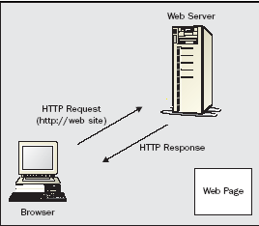

Client and server communication without PHP
Here's what's happening in the numbered steps of the diagram:
- If we type www.example.com/catalog.html into the location bar of Internet Explorer,
- Internet Explorer sends a message over the Internet to the computer named www.example.com asking for the /catalog.html page.
- Apache, a program running on the www.example.com computer, gets the message and reads the catalog.html file from the disk drive.
- Apache sends the contents of the file back to our computer over the Internet as a response to Internet Explorer's request.
- Internet Explorer displays the page on the screen, following the instructions of the HTML tags in the page.
Every time a browser asks for http://www.example.com/catalog.html, the web server sends back the contents of the same catalog.html file. The only time the response from the web server changes is if someone edits the file on the server. The following figure shows Client and server communication without PHP

WEB BROWSER
OUTLOOK
WORD
SOLITAIRE
“www.example.com,
Please send me /catalog.html”

APACHE
DISK DRIVE
INTER -NET
ADDRESS http://www.example.com/catalog.html
YOUR PAGE
3

4
1
2
5
Client and server communication with PHP

WEB BROWSER
OUTLOOK
WORD
SOLITAIRE
“www.example.com,
Please send me /catalog. sample.php”

APACHE

PHP
DISK DRIVE
INTER
NET
ADDRESS http://www.example.com/catalog. sample.php
YOUR PAGE
3

6
1
2
8
MY SQL
7

5

4

- If we type www.example.com/catalog/ sample.php into the location bar of Internet Explorer,
- Internet Explorer sends a message over the Internet to the computer named www.example.com asking for the /catalog/ sample.php page.
- Apache, a program running on the www.example.com computer, gets the message and asks the PHP interpreter, another program running on the www.example.com computer, "What does /catalog/sample.php look like?"

- The PHP interpreter reads the file /usr/local/www/catalog/ sample.php from the disk drive.
- The PHP interpreter runs the commands in sample.php, possibly exchanging data with a database program such as MySQL.
- The PHP interpreter takes the yak.php program output and sends it back to Apache as an answer to "What does /catalog/ sample.php look like?"
- Apache sends the page contents it got from the PHP interpreter back to our computer over the Internet in response to Internet Explorer's request.
- Internet Explorer displays the page on the screen, following the instructions of the HTML tags in the page

Implementation

Web Form Design:

The user fills out the various text boxes and clicks a submit button when ready; the information that is supplied is then bundled up in one of two ways and sent to the web server. The web servers can then pull out this information, and supply it to the PHP script engine. PHP manipulates this information and sends it back as part of the HTTP response to the browser. All you need to do to make a form is create a pure HTML web page with opening and closing <FORM> tags. Any controls such as text field, check boxes, and radio buttons that are placed between the <FORM> tags, automatically become part of the form that is sent to the web server
<form name=”xyz” action=”another.php” method=”post”>
We used the post method. Because it was the secure method to transfer the client information to server. Another important tag is <input>. It is used to design the textbox, check box, radio button, command button and so on. This control is used to get the information from the user.

Input Validation:
We can check the user input using two methods. One is client side and another one is server side. We can check the correct format of the input using client side code.

If we check the data from the database or in server, we will check using the server side script. In client side program, we used JavaScript. PHP is used to validate the input in server side.

Display the shopping:

The entire exam lists are stored in MySQL database. PHP parsed the MySQL query and sent back to the user. User can choose the exam and take the exam. Exam questions are displayed using AJAX techniques. It is very useful for interaction between the client and server. User need not wait for the next question. AJAX is processed fast and returned back to client screen.We used the following sample code for display the exam.

About PHP:
PHP is a general-purpose server-side scripting language originally designed for web development to produce dynamic web pages. It is among one of the first developed server-side scripting languages that is embedded into a HTML source document, rather than calling an external file to process data. Ultimately, the code is interpreted by a web server with a PHP processor module which generates the resulting web page. It also has evolved to include a command-line interface capability and can be used in standalone graphical applications. PHP can be deployed on most web servers and also as a standalone shell on almost every operating system and platform free of charge. A competitor to Microsoft's Active Server Pages (ASP) server-side script engine and similar languages, PHP is installed on more than 20 million websites and 1 million web servers.

PHP stands for PHP: Hypertext Preprocessor.
- As we said before it is a server-side scripting language.
- PHP is free and is an open source software product.
- The PHP scripts are executed on the server.
- PHP supports many databases (MySQL, Sybase, Oracle and many others.)
- PHP runs on different platforms (Unix, Linux, Windows.)
- PHP is compatible with almost all web-servers used today (Apache, IIS, etc.)
- A PHP file can contain plain text, HTML tags and scripts
- The PHP files can have one of the following extensions: php, php3 or phtml.

What do you need?
Before you can follow the coming PHP tutorials you need to have the following:
- Access to a web server (like Apache)
- PHP and MySQL should be installed on the web server.
The easiest way is to find a cheap web hosting plan that support PHP and MySQL (most of the web-hosting providers do.) For a couple of bucks a month you can get a virtual host. The advantage is that everything is already installed and that you can share your program (that you are going to write) with the rest of the world.
If you don’t want to spend money, you can also install everything on your local machine. The easiest way is to install WAMP if you have a Windows machine and LAMP if you have a Linux machine. (WAMP = Windows Apache MySQL PHP and LAMP = Linux Apache MySQL PHP.) These packages install everything you need. Read the install manual of these packages for instructions. After installation you should have access to http://localhost in your browser.
That is all for this PHP language introduction tutorial. We hope that you will learn something from the coming PHP tutorials and as always we hope that you will let us know if something is wrong by leaving us a comment.
Before we can start coding you first need to know some basics. In this PHP language introduction tutorial you’ll find some descriptions of words you should know before you can start coding. Of course we will also look at where you can download PHP, MySQL and Apache.
PHP is probably the most popular scripting language on the web. It is used to enhance web pages. With PHP, you can do things like create username and password login pages, check details from a form, create forums, picture galleries, surveys, and a whole lot more. If you've come across a web page that ends in PHP, then the author has written some programming code to liven up the plain, old HTML.
PHP is known as a server-sided language. That's because the PHP doesn't get executed on your computer, but on the computer you requested the page from. The results are then handed over to you, and displayed in your browser. Other scripting languages you may have heard of are ASP, Python and Perl. (You don't need to know any of these to make a start on PHP. In fact, these tutorials assume that you have no programming experience at all.)
The most popular explanation of just what PHP stands for is "Hypertext Pre-processor". But that would make it HPP, surely? An alternative explanation is that the initials come from the earliest version of the program, which was called Personal Home Page Tools. At least you get the letters "PHP" in the right order!
But PHP is so popular that if you're looking for a career in the web design/web scripting industry then you just have to know it! In these tutorials, we'll get you up and running. And, hopefully, it will be a lot easier than you think.

Course Files
To follow along with these tutorials, you'll need our Home and Learn Course files. These can be downloaded from the following address:
The PHP programming language is a server-side HTML embedded scripting language.
Let‘s depict the sentence. The PHP language runs on the server-side. This means that the execution (read starting) of the scripts are done on the server where the web-site is hosted. HTML embedded means that you can use PHP statements (read a piece of PHP code) from within an HTML code. PHP files are returned to the browser as plain HTML.
The last piece of the sentence – scripting language – is a little harder to explain, but we will give it a go. A scripting language is a form of programming language that is usually interpreted rather than compiled. In programming languages such C or C++ you compile the program (permanently) into an executable file, before you can execute the program. A program that is written in a scripting language, is interpreted one command at a time by a command interpreter (Command interpreter is in most cases an executable written in another language (for instance C/C++) than the scripting language.) Some other examples of scripting languages are Perl, Phyton, Java and Ruby.
A last note: scripting languages are also often used by applications as control or configure language. An example: Firefox is written in C/C++ and can be controlled with JavaScript.

Things You Should Know
Because PHP is an HTML embedded language you should have a basic understanding of HTML/XHTML and (a little) JavaScript. In the coming tutorials we will explain the PHP code, but we won’t explain the HTML code (at least not in great detail.)
Architecture Of PHP

The mysqlnd replication and load balancing plugin is implemented as a PHP extension. It is written in C and operates under the hood of PHP. During the startup of the PHP interpreter, in the module init phase of the PHP engine, it gets registered as a mysqlnd plugin to replace selected mysqlnd C methods.

At PHP runtime, it inspects queries sent from mysqlnd (PHP) to the MySQL server. If a query is recognized as read-only, it will be sent to one of the configured slave servers. Statements are considered read-only if they either start with SELECT, the SQL hint /*ms=slave*/ or a slave had been chosen for running the previous query, and the query started with the SQL hint /*ms=last_used*/. In all other cases, the query will be sent to the MySQL replication master server.

For better portability, applications should use the MYSQLND_MS_MASTER_SWITCH, MYSQLND_MS_SLAVE_SWITCH, and MYSQLND_MS_LAST_USED_SWITCH predefined mysqlnd_ms constants, instead of their literal values, such as /*ms=slave*/.

The plugin handles the opening and closing of database connections to both master and slave servers. From an application point of view, there continues to be only one connection handle. However, internally, this one public connection handle represents a pool of network connections that are managed by the plugin. The plugin proxies queries to the master server, and to the slaves using multiple connections.

Database connections have a state consisting of, for example, transaction status, transaction settings, character set settings, and temporary tables. The plugin will try to maintain the same state among all internal connections, whenever this can be done in an automatic and transparent way. In cases where it is not easily possible to maintain state among all connections, such as when using BEGIN TRANSACTION, the plugin leaves it to the user to handle.

History of PHP
PHP Tools, FI, Construction Kit, and PHP/FI

PHP as it's known today is actually the successor to a product named PHP/FI. Created in 1994 by Rasmus Lerdorf, the very first incarnation of PHP was a simple set of Common Gateway Interface (CGI) binaries written in the C programming language. Originally used for tracking visits to his online resume, he named the suite of scripts "Personal Home Page Tools," more frequently referenced as "PHP Tools." Over time, more functionality was desired, and Rasmus rewrote PHP Tools, producing a much larger and richer implementation. This new model was capable of database interaction and more, providing a framework upon which users could develop simple dynamic web applications such as guestbooks. In June of 1995, Rasmus » released the source code for PHP Tools to the public, which allowed developers to use it as they saw fit. This also permitted - and encouraged - users to provide fixes for bugs in the code, and to generally improve upon it.

In September of that year, Rasmus expanded upon PHP and - for a short time - actually dropped the PHP name. Now referring to the tools as FI (short for "Forms Interpreter"), the new implementation included some of the basic functionality of PHP as we know it today. It had Perl-like variables, automatic interpretation of form variables, and HTML embedded syntax. The syntax itself was similar to that of Perl, albeit much more limited, simple, and somewhat inconsistent. In fact, to embed the code into an HTML file, developers had to use HTML comments. Though this method was not entirely well-received, FI continued to enjoy growth and acceptance as a CGI tool --- but still not quite as a language. However, this began to change the following month; in October, 1995, Rasmus released a complete rewrite of the code. Bringing back the PHP name, it was now (briefly) named "Personal Home Page Construction Kit," and was the first release to boast what was, at the time, considered an advanced scripting interface. The language was deliberately designed to resemble C in structure, making it an easy adoption for developers familiar with C, Perl, and similar languages. Having been thus far limited to UNIX and POSIX-compliant systems, the potential for a Windows NT implementation was being explored.

The code got another complete makeover, and in April of 1996, combining the names of past releases, Rasmus introduced PHP/FI. This second-generation implementation began to truly evolve PHP from a suite of tools into a programming language in its own right. It included built-in support for DBM, mSQL, and Postgres95 databases, cookies, user-defined function support, and much more. That June, PHP/FI was given a version 2.0 status. An interesting fact about this, however, is that there was only one single full version of PHP 2.0. When it finally graduated from beta status in November, 1997, the underlying parsing engine was already being entirely rewritten.

Though it lived a short development life, it continued to enjoy a growing popularity in still-young world of web development. In 1997 and 1998, PHP/FI had a cult of several thousand users around the world. A Netcraft survey as of May, 1998, indicated that nearly 60,000 domains domains reported having headers containing "PHP," indicating that the host server did indeed have it installed. This number equated to approximately 1% of all domains on the Internet at the time. Despite these impressive figures, the maturation of PHP/FI was doomed to limitations; while there were several minor contributors, it was still primarily developed by an individual.
Features of PHP:

i) HTTP authentication with PHP
It is possible to use the header () function to send an "Authentication Required" message to the client browser causing it to pop up a Username/Password input window. Once the user has filled in a username and a password, the URL containing the PHP script will be called again with the predefined variables PHP_AUTH_USER, PHP_AUTH_PW, and AUTH_TYPE set to the user name, password and authentication type respectively. These predefined variables are found in the $_SERVER and $HTTP_SERVER_VARS arrays. Both "Basic" and "Digest" (since PHP 5.1.0) authentication methods are supported. See the header () function for more information.

ii) Cookies
PHP transparently supports HTTP cookies. Cookies are a mechanism for storing data in the remote browser and thus tracking or identifying return users. You can set cookies using the set cookie () or setrawcookie() function. Cookies are part of the HTTP header, so set cookie () must be called before any output is sent to the browser. This is the same limitation that header () has. You can use the output buffering functions to delay the script output until you have decided whether or not to set any cookies or send any headers.
Any cookies sent to you from the client will automatically be included into a $_COOKIE auto-global array if variables order contains "C". If you wish to assign multiple values to a single cookie, just add [] to the cookie name.
Depending on register_globals, regular PHP variables can be created from cookies. However it's not recommended to rely on them as this feature is often turned off for the sake of security. $HTTP_COOKIE_VARS is also set in earlier versions of PHP when the track_vars configuration variable is set.

iii) New features
PHP 5.3.0 offers a wide range of new features:
- Support for namespaces has been added.
- Support for Late Static Bindings has been added.
- Support for jump labels (limited goto) has been added.
- Support for native Closures (Lambda/Anonymous functions) has been added.
- There are two new magic methods, __callStatic and __invoke.
- Nowdoc syntax is now supported, similar to Heredoc syntax, but with single quotes.
- It is now possible to use Heredocs to initialize static variables and class properties/constants.
- Heredocs may now be declared using double quotes, complementing the Nowdoc syntax.
- Constants can now be declared outside a class using the const keyword.
- The ternary operator now has a shorthand form: ?:.
- The HTTP stream wrapper now considers all status codes from 200 to 399 to be successful.
- Dynamic access to static methods is now possible.
- Exceptions can now be nested.
- A garbage collector for circular references has been added, and is enabled by default.
- The mail() function now supports logging of sent email. (Note: This only applies to email sent through this function.)
Advantages of PHP:
- PHP (Hypertext Pre-Processor) is a server-side web programming language that is widely used for web development.
However, here are many languages which are used for web development or web programming. But among all of them PHP is the most popular web scripting language. So, let us find out why PHP is widely used for web development…
- PHP language has its roots in C and C++. PHP syntax is most similar to C and C++ language syntax. So, programmers find it easy to learn and manipulate.
- MySQL is used with PHP as back-end tool. MySQL is the popular online database and can be interfaced very well with PHP. Therefore, PHP and MySQL are excellent choice for webmasters looking to automate their web sites.
- PHP can run on both UNIX and Windows servers.
- PHP also has powerful output buffering that further increases over the output flow. PHP internally rearranges the buffer so that headers come before contents.
- PHP is dynamic. PHP works in combination of HTML to display dynamic elements on the page. PHP only parses code within its delimiters, such as. Anything outside its delimiters is sent directly to the output and not parsed by PHP.
- PHP can be used with a large number of relational database management systems, runs on all of the most popular web servers and is available for many different operating systems.
- PHP5 a fully object oriented language and its platform independence and speed on Linux server helps to build large and complex web applications.
- So, in general PHP is cheap, secure, fast and reliable for developing web applications.

About MySQL:

MySQL is a relational database management system (RDBMS)] that runs as a server providing multi-user access to a number of databases. The SQL phrase stands for Structured Query Language. Free-software-open source projects that require a full-featured database management system often use MySQL. For commercial use, several paid editions are available, and offer additional functionality. Applications which use MySQL databases include: TYPO3, Joomla, WordPress, phpBB, Drupal and other software built on the LAMP software stack. MySQL is also used in many high-profile, large-scale World Wide Web products, including Wikipedia, Google , Facebook, and Twitter.
MySQL is the world's most popular open source database software, with over 100 million copies of its software downloaded or distributed throughout it's history. With its superior speed, reliability, and ease of use, MySQL has become the preferred choice for Web, Web 2.0, SaaS, ISV, Telecom companies and forward-thinking corporate IT Managers because it eliminates the major problems associated with downtime, maintenance and administration for modern, online applications.
Many of the world's largest and fastest-growing organizations use MySQL to save time and money powering their high-volume Web sites, critical business systems, and packaged software — including industry leaders such as Yahoo!, Alcatel-Lucent, Google, Nokia, YouTube, Wikipedia, and Booking.com.
The flagship MySQL offering is MySQL Enterprise, a comprehensive set of production-tested software, proactive monitoring tools, and premium support services available in an affordable annual subscription.
MySQL is a key part of LAMP (Linux, Apache, MySQL, PHP / Perl / Python), the fast-growing open source enterprise software stack. More and more companies are using LAMP as an alternative to expensive proprietary software stacks because of its lower cost and freedom from platform lock-in.
MySQL was originally founded and developed in Sweden by two Swedes and a Finn: David Axmark, Allan Larsson and Michael "Monty" Widenius, who had worked together since the 1980's. More historical information on MySQL is

SYSTEM DESIGN
DATA FLOW DIAGRAMS

A data flow diagram is graphical tool used to describe and analyze movement of data through a system. These are the central tool and the basis from which the other components are developed. The transformation of data from input to output, through processed, may be described logically and independently of physical components associated with the system. These are known as the logical data flow diagrams. The physical data flow diagrams show the actual implements and movement of data between people, departments and workstations. A full description of a system actually consists of a set of data flow diagrams. Using two familiar notations Yourdon, Gane and Sarson notation develops the data flow diagrams. Each component in a DFD is labeled with a descriptive name. Process is further identified with a number that will be used for identification purpose. The development of DFD’S is done in several levels. Each process in lower level diagrams can be broken down into a more detailed DFD in the next level. The lop-level diagram is often called context diagram. It consists a single process bit, which plays vital role in studying the current system. The process in the context level diagram is exploded into other process at the first level DFD.
The idea behind the explosion of a process into more process is that understanding at one level of detail is exploded into greater detail at the next level. This is done until further explosion is necessary and an adequate amount of detail is described for analyst to understand the process.
Larry Constantine first developed the DFD as a way of expressing system requirements in a graphical from, this lead to the modular design.
A DFD is also known as a “bubble Chart” has the purpose of clarifying system requirements and identifying major transformations that will become programs in system design. So it is the starting point of the design to the lowest level of detail. A DFD consists of a series of bubbles joined by data flows in the system.

DFD SYMBOLS:
In the DFD, there are four symbols
- A square defines a source(originator) or destination of system data
- An arrow identifies data flow. It is the pipeline through which the information flows
- A circle or a bubble represents a process that transforms incoming data flow into outgoing data flows.
- An open rectangle is a data store, data at rest or a temporary repository of data

Process that transforms data flow.

Source or Destination of data
Data flow

Data Store

CONSTRUCTING A DFD:
Several rules of thumb are used in drawing DFD’S:

- Process should be named and numbered for an easy reference. Each name should be representative of the process.
- The direction of flow is from top to bottom and from left to right. Data traditionally flow from source to the destination although they may flow back to the source. One way to indicate this is to draw long flow line back to a source. An alternative way is to repeat the source symbol as a destination. Since it is used more than once in the DFD it is marked with a short diagonal.
- When a process is exploded into lower level details, they are numbered.
- The names of data stores and destinations are written in capital letters. Process and dataflow names have the first letter of each work capitalized

A DFD typically shows the minimum contents of data store. Each data store should contain all the data elements that flow in and out.
Questionnaires should contain all the data elements that flow in and out. Missing interfaces redundancies and like is then accounted for often through interviews.

SAILENT FEATURES OF DFD’S
- The DFD shows flow of data, not of control loops and decision are controlled considerations do not appear on a DFD.
- The DFD does not indicate the time factor involved in any process whether the dataflow take place daily, weekly, monthly or yearly.
- The sequence of events is not brought out on the DFD.

TYPES OF DATA FLOW DIAGRAMS
- Current Physical
- Current Logical
- New Logical
- New Physical

CURRENT PHYSICAL:
In Current Physical DFD process label include the name of people or their positions or the names of computer systems that might provide some of the overall system-processing label includes an identification of the technology used to process the data. Similarly data flows and data stores are often labels with the names of the actual physical media on which data are stored such as file folders, computer files, business forms or computer tapes.

CURRENT LOGICAL:
The physical aspects at the system are removed as much as possible so that the current system is reduced to its essence to the data and the processors that transform them regardless of actual physical form.

NEW LOGICAL:
This is exactly like a current logical model if the user were completely happy with he user were completely happy with the functionality of the current system but had problems with how it was implemented typically through the new logical model will differ from current logical model while having additional functions, absolute function removal and inefficient flows recognized.

NEW PHYSICAL:
The new physical represents only the physical implementation of the new system.

RULES GOVERNING THE DFD’S

PROCESS
- No process can have only outputs.
- No process can have only inputs. If an object has only inputs than it must be a sink.
- A process has a verb phrase label.

DATA STORE
- Data cannot move directly from one data store to another data store, a process must move data.
- Data cannot move directly from an outside source to a data store, a process, which receives, must move data from the source and place the data into data store
- A data store has a noun phrase label.

SOURCE OR SINK
The origin and /or destination of data.

- Data cannot move direly from a source to sink it must be moved by a process
- A source and /or sink has a noun phrase land

DATA FLOW
- A Data Flow has only one direction of flow between symbols. It may flow in both directions between a process and a data store to show a read before an update. The later is usually indicated however by two separate arrows since these happen at different type.
- A join in DFD means that exactly the same data comes from any of two or more different processes data store or sink to a common location.
- A data flow cannot go directly back to the same process it leads. There must be atleast one other process that handles the data flow produce some other data flow returns the original data into the beginning process.
- A Data flow to a data store means update (delete or change).
- A data Flow from a data store means retrieve or use.

A data flow has a noun phrase label more than one data flow noun phrase can appear on a single arrow as long as all of the flows on the same arrow move together as one package.

LEVELS OF DFD:

The complexity of the business system means that it is a responsible to represent the operations of any system of single data flow diagram. At the top level, an Overview of the different systems in an organization is shown by the way of context analysis diagram. When exploded into DFD
They are represented by:
- LEVEL-0 : SYSTEM INPUT/OUTPUT
- LEVEL-1:SUBSYSTEM LEVEL DATAFLOW FUNCTIONAL
- LEVEL-2 : FILE LEVEL DETAIL DATA FLOW.
The input and output data shown should be consistent from one level to the next.

LEVEL-0: SYSTEM INPUT/OUTPUT LEVEL
A level-0 DFD describes the system-wide boundaries, dealing inputs to and outputs from the system and major processes. This diagram is similar to the combined user-level context diagram.

LEVEL-1: SUBSYSTEM LEVEL DATA FLOW
A level-1 DFD describes the next level of details within the system, detailing the data flows between subsystems, which makeup the whole.

LEVEL-2: FILE LEVEL DETAIL DATA FLOW
All the projects are feasible given unlimited resources and infinite time. It is both necessary and prudent to evaluate the feasibility of the project at the earliest possible time. Feasibility and the risk analysis are pertained in many ways. If project risk is great.
System Design

Conceptual Design

Overall Flow Diagram

Start

User Registration

Login

Display the Product Category

Choose the product

A
B
Purchase The Product
View the product

Payment Details

A
B
End of the session
Logout

UML DATA

The UML’s four structural diagram exists to visualize, specify, construct and document the static aspects of system. Just as the static aspects of a house encompass the existence and placement of such things as walls, doors, windows, pipes, wires and vents. So to do the static aspects of a software system encompass the existence and placement of such things classes, interfaces, collaborations, components and nodes.

The UML’s structural diagrams are roughly organized around the major groups of things you will find when modeling a system.

- CLASS DIAGRAM: classes, interfaces and collaborations
- OBJECT DIAGRAM: objects
- COMPONENT DIAGRAM: components
- DEPLOYMENT DIAGRAM: nodes.

CLASS DIAGRAM:
A class diagram shows a set of classes, interfaces, collaborations and their relationships. Class diagrams are the most common diagrams found in modeling object – oriented system. Class diagram that includes active classes are used to address the static process view of a system.

COMPONENT DIAGRAM:
A component diagram shows a set of components and their relationships. Component diagrams are related to class diagrams in that component typically maps to one or more classes, interfaces or collaborations. It is used to illustrate the static implementation view of a system.

DEPLOYMENT DIAGRAM:
A deployment diagrams shows a set of nodes and their relationships deployment diagrams are related to component diagrams in that node typically encloses one or more components.

USECASE DIAGRAMS:
A use case diagram shows as set of use cases and actors and their relationships. Use case diagrams are especially important in organizing and modeling behavior of a system.

SEQUENCE DIAGRAM:
A sequence diagram is an interaction diagram that emphasizes the time ordering of messages. A sequence diagram shows a set of objects and messages sent and receive by those objects. The objects are typically named or anonymous instances of other things, such as collaborations, components and nodes. We can use sequence diagrams to illustrate the dynamic view of a system.

COLLABORATION DIAGRAM:
A collaboration diagram is an inter action diagram that emphasizes the structural organization of the objects that send and receive messages. It shows a set of objects, links among those objects and messages sent and receive by the objects. The objects are typically named or anonymous instances of classes but may also represent instance of other things such as collaborations, components and nodes.

RELATIONSHIPS

Dependency:
Dependency is a semantic relationship between two things in which change to one thing may affect the semantics of other things.
Graphically a dependency rendered as a dashed-line, possibly directed occasionally including a label.

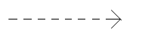
Fig: Dependency

Association:
Association is a structural relationship that describes set of links.
a link being a connection among objects. Aggregation is a special kind of association a structural relationship between a whole and its parts.
It is graphically rendered as a solid-line. Such as multiplicity and role names.

_________________
Employer employee
Fig: Association

Generalization:
Generalization is a specialization/generalization relationship in which objects of specialized element (child) are substitutable for object of the generalized element (parent).in this way the child shares the structure and behavior of the parent.
Graphically rendered as a solid-line with a hollow over-head pointing to the parent.

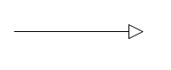
Fig: Generalization

Realization:
A realization is a semantic relationship between classifiers. Where in one classifier specifies a contract that another classifier guarantees to carry-out you will encounter relationships in two places between interfaces and classes or components between use case collaborations.Graphically rendered as cross between generalization and dependency relationships.
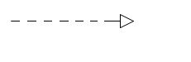
Fig: Realization

Class:
A class is a description of set of objects and the same attributes, operations relationships and semantics. A class implements one or more interfaces.
Graphically rendered as a rectangle, usually including a name, attributes and operations.
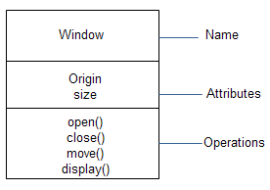
Fig: Classes

Use case:
Use case is a description of set of sequence of actions that a system performs that yields an observable result of value to a particular actor.
Graphically rendered as an ellipse with solid-lines, usually including only its names.

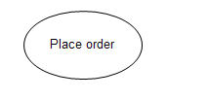
Fig: Use case

Collaborations:
Collaboration defines an interaction is a society of roles and other elements that work together to provide some co-operative behavior that’s bigger than the some of elements. Therefore collaborations have structural as well as behavioral dimensions.
Graphically rendered as an ellipse with dashed-lines usually including only its names.

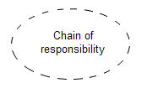
Fig: collaboration

UML DIAGRAMS

Use case diagram :

Usecase analysis:
The use case diagram is used to identify the primary element and processes. That form the system the primary element are termed as “actors” and the processes are called “use cases”. The use case diagram show which actors interacts with each use case.
Use case diagram of UML are used to view system from this perspective as a set of discrete Activities or transactions. A ellipse represents a use case and a
“Stick figure” represents an actor operating with in the use case.
- An actor can be user, system or other entity.
- The initiating actor appears on the left of the use case and the receiving actor appears on the right.
- The actor is identified by a name below the “stick figure”
- The name of the use case appears either in the side or below the ellipse.
- An association line is a that connects an actor and to the use case and represents communication between the actor and use cases
- The association line is solid similar to the line that connect associated classes.
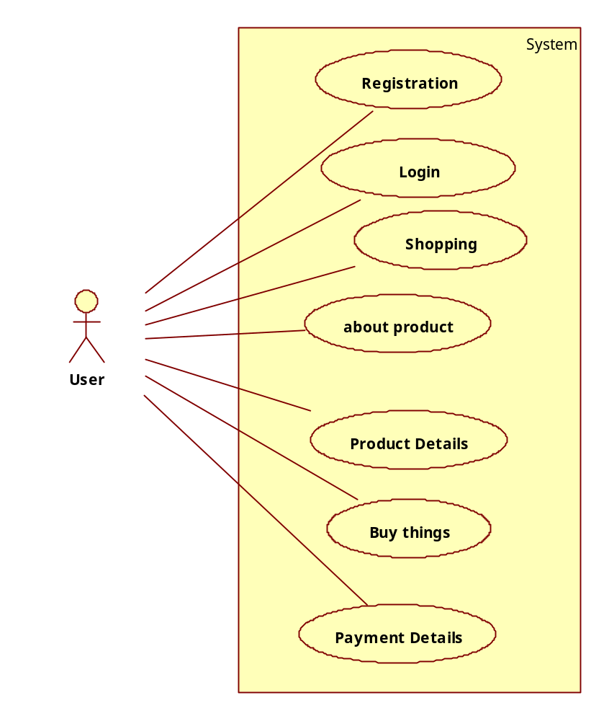

Sequence Diagram

User
Apache
PHP
MySQL

Registration
Check the username is available or not
Process the Query
Login
Process the Query
Display the Product list
Request the Product
Session Created
Process the Query
Purchase the Product
User
Apache
PHP
MySQL

Next product to purchase
Process the Query
Process the Query
Request the Payment
Process the Query
Logout
Session Ended
Display the Product Price
Display the Payment Details
Data Base Design:

Buyer Table:

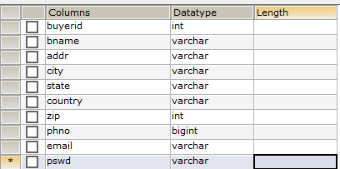

Booking Table:

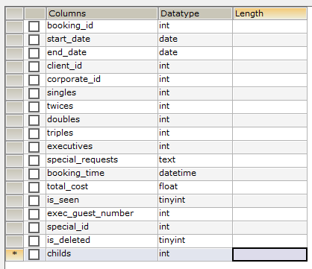

Clients Table:

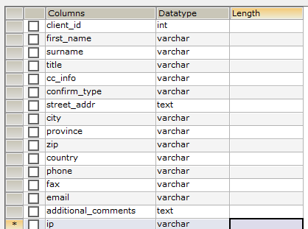

Corporates Table:

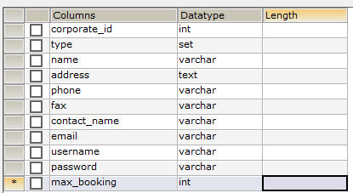

Inventory Table:
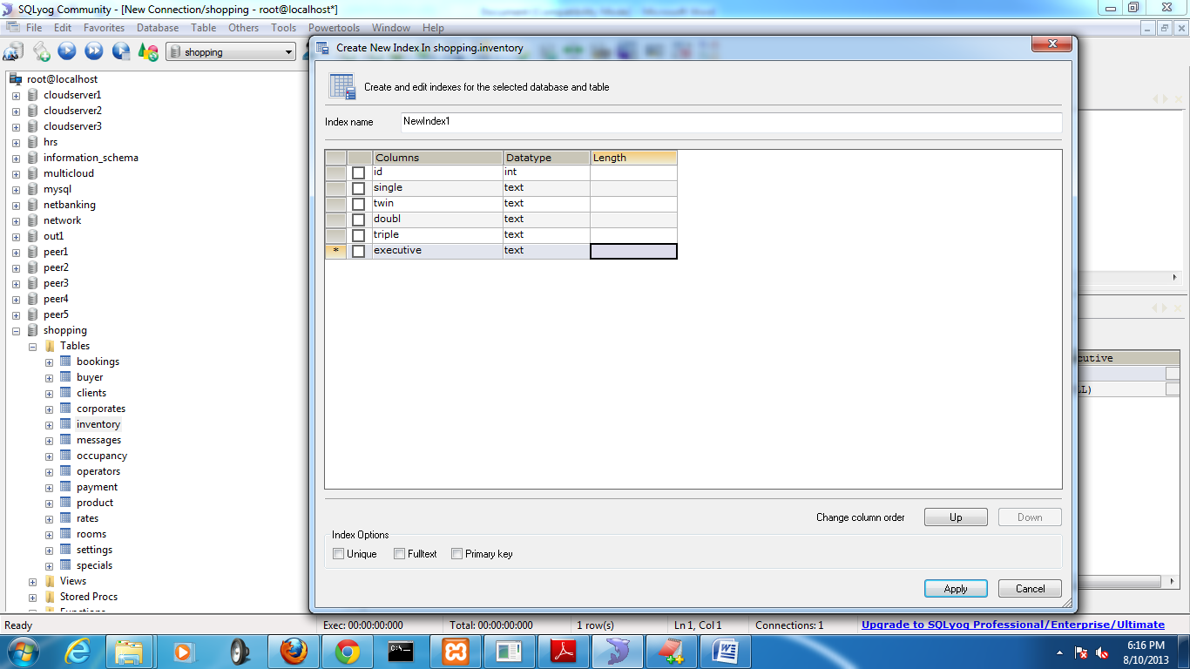
Messages Table:
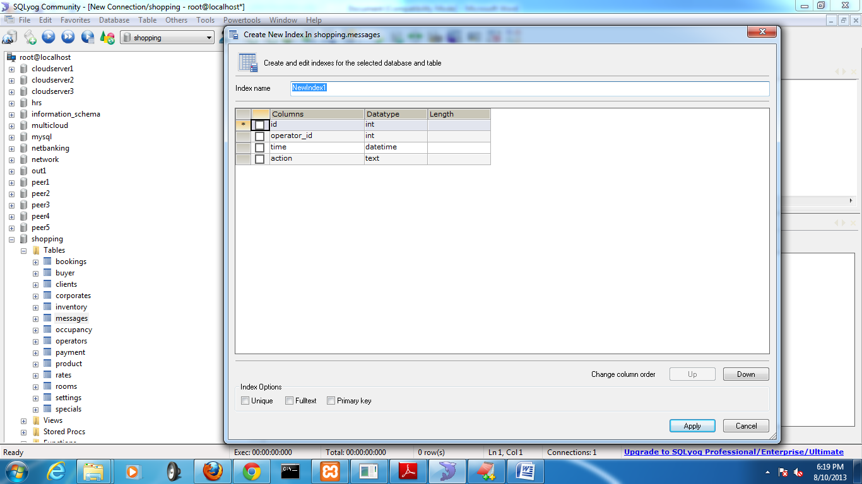

Occupancy Table:
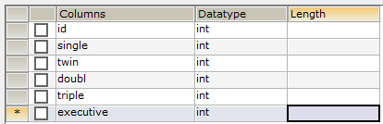

Operators Table:
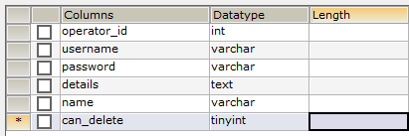
Payment Table:
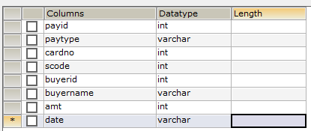
Product Table:
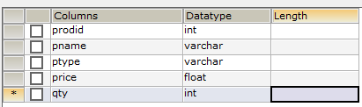

Rates Table:
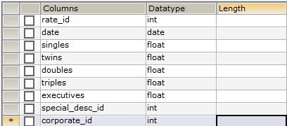
Rooms Table:
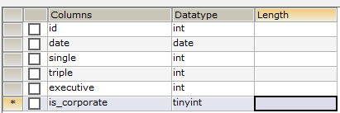

Settings Table:
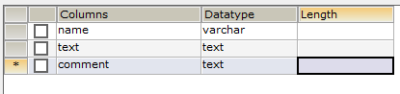
Specials Table:
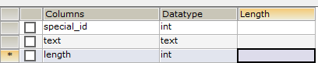
Sample Client Side Script:
function examrsout()
{
if (xmlHttp.readyState == 4)
{
if (xmlHttp.status == 200)
{ noch=xmlHttp.responseXML.getElementsByTagName("nochoice")[0].childNodes[0].nodeValue;
if(noch.charAt(0)=='P')
document.getElementById('qno').innerHTML='Q.No.' + xmlHttp.responseXML.getElementsByTagName("qno")[0].childNodes[0].nodeValue;
else
document.getElementById('qno').innerHTML="";
if(noch.charAt(1)=='P')
{ document.getElementById('question').innerHTML=xmlHttp.responseXML.getElementsByTagName("question")[0].childNodes[0].nodeValue;
}
else
{
document.getElementById('question').innerHTML="";
}
}

Sample Server Side Script:

<?php
header('Content-Type: text/xml');
echo '<?xml version="1.0" encoding="UTF-8" standalone="yes"?>';
echo '<response>';
if(isset($_GET['rspos']))
{
$rspos=$_GET['rspos'];
$nchoice="";
include '../dbconnect.php';
$ename=$_SESSION['exname'];
$sql="select * from onlinetlist where test_name='$ename' ";
$exdbres=$dbconn->query($sql)or die($dbconn->errorInfo());
$exdbres->setFetchMode(PDO::FETCH_ASSOC);
while($exdbrs=$exdbres->fetch())
{
$exdbname=$exdbrs['test_dbname'];
}
$sql="select * from $exdbname where q_no='$rspos' ";
$qrs=$dbconn->query($sql) or die($dbconn->errorInfo());
$qrs->setFetchMode(PDO::FETCH_ASSOC);
}
?>

SYSTEM TESTING

TESTING CONCEPTS FOR WEB APPLICATIONS
Testing is the process of exercising software with the intent of finding (and ultimately correcting) errors. In fact, because Web-based systems and applications reside on a network and interoperate with many different operating systems and applications reside on a network and interoperate with many different operating systems, browsers (or other interface devices as PDAs or mobile phones), hardware platforms, communications protocols, and “backroom” applications, the search for errors represents a significant challenge.

Errors within a WebApp Environment:
Errors encountered as a consequence of successful WebApp testing have a number of unique characteristics:
  - Because many types of WebApp tests uncover problems that are first evidenced on the client side (i.e., via an interface implemented on a specific browser or a PDA or a mobile phone).
  - Because a WebApp is implemented in a number of different configurations and within different environments, it may be difficult or impossible to reproduce an error outside the environment in which the error was originally encountered.
  - Although some errors are the result of incorrect design or improper HTML (or other programming language) coding, many errors can be traced to the WebApp configuration.
  - Because WebApps reside within client/server architecture, errors can be difficult to trace across three architectural layers: the client, the server, or the networkitself.
  - Some errors are due to the static operating environment (i.e., the specific configuration in which testing is conducted), while others are attributable to the dynamic operating environment (i.e., instantaneous resource loading or time-related errors).

2 Testing Strategy:

Basic principles for software testing of WebApps are
- The Content Model for the WebApp is reviewed to uncover errors.
- The interface model is reviewed to ensure that all use-cases can be accommodated.
- The design model for the WebApp is reviewed to uncover navigation errors.
- The user interface is tested to uncover errors in presentation and/or navigation mechanics.
- Selected functional components are unit tested.
- Navigation throughout the architecture is tested.
- The WebApp is implemented in a variety of different environmental configurations and is tested for compatibility with each configuration.
- Security tests are conducted in an attempt to exploit vulnerabilities in the WebApp or within its environment.
- Performance tests are conducted.
- The WebApp is tested by a controlled and monitored population of end users; the results of their interaction with the system are evaluated for content and navigation errors, usability concerns, compatibility concerns, and WebApp reliability and performance.

Test Planning:

A WebApp test plan identifies
- A task set to be applied as testing commences.
- The work products to be produced as each testing task are executed.
- The manner in which the results of testing are evaluated, recorded, and reused when regression testing is conducted.

THE TESTING PROCESS- OVERVIEW:

The testing process for web engineering begins with tests that exercise content and interface functionality that is immediately visible to end-users. As testing proceeds, aspects of the design architecture and navigation are exercised. The user may or may not be cognizant of these WebApp elements. Finally, the focus shifts to tests that exercise technological capabilities that are not always apparent to end-users—WebApp infrastructure and installation/implementation issues.
- Content Testing
- Interface Testing
- Navigation Testing
- Component Testing
- Configuration Testing
- Performance Testing
- Security Testing

The following figure shows the testing flow:

Content testing
Interface testing
Navigation testing
Interface design
Aesthetic design
Content design
Navigation design
Architecture design
Component design
Configuration testing
Performance testing
Security testing
Component testing
Technology
User

CONTENT TESTING:
Errors in WebApp content can be as trivial as minor typological errors or as significant as incorrect information, improper organization, or violation of intellectual property laws. Content testing attempts to uncover these and many other problems before the user encounters them.

Content Testing Objectives:
Content testing has three important objectives:
- To uncover syntactic errors(e.g., typos, grammar mistakes) in text-based documents, graphical representations, and other media
- To uncover semantic errors (i.e., errors in the accuracy or completeness of information) in any content object presented as navigation occurs
- To find errors in the organization or structure of content that is presented to the end-user.
In our system testing
In the ASP.NET technology, we have intelligence facility so that we can avoid syntactic errors while we are doing coding without putting extra effort for detecting these types of errors. Semantic testing focuses on the information presented within each content object. The tester must answer the following questions:
- Is the information factually accurate?
- Is the information concise and to the point?
- Is the layout of the content object easy for the user to understand?
- Can information embedded within a content object be found easily?
- Have proper references been provided for all information derived from other sources?
- Is the information presented consistent internally and consistent with information presented in other content objects?
- Is the content offensive, misleading, or does it open the door to litigation?
- Does the content infringe on existing copyrights or trademarks?
- Does the content contain internal links that supplement existing content? Are the links correct?
- Does the aesthetic style of the content conflict with the aesthetic style of the interface?

In our system:
It presents a variety of information about the various groups. Content objects provide descriptive information, photographic representations and related information. We provide different ads in the websites.

Database Testing:
Modern web applications do much more than present static content objects. In many application domains, WebApps interface with sophisticated database management systems and build dynamic content objects that are created in real-time using the data acquired from a database.
In our system also, the user can view all the information containing in any group which is retrieved from the database, if the user wants to download then only he can download the files, photos, videos, etc. which is also accessed from the database and present those details in the content object.
Database Testing for WebApps is complicated by a variety of factors:

- The original client-side request for information is rarely presented in the form that can be input to a database management system. Therefore, tests should be designed to uncover errors made by these DBMS.
- The database may be remote to the server that houses the WebApp. Therefore, tests that uncover errors in communication between the WebApp and the remote database should be developed.
- Raw data acquired from the database must be transmitted to the WebApp server and properly formatted for subsequent transmittal to the client. Therefore, tests that demonstrate the validity of the raw data received by the WebApp server should be developed, and additional tests that demonstrate the validity of the transformations applied to the raw data to create valid content objects must also be created.
- The dynamic content objects must be transmitted to the client in a form that can be displayed to the end-user. Therefore, a series of tests should be developed to uncover errors in the content object format and test compatibility with different client environment configurations.

USER INTERFACE TESTING:
Verification and validation of a WebApp user interface occurs at three distinct points in the Web engineering process. During formulation and requirements analysis, the interface model is reviewed to ensure that it confirms to customer requirements and to other elements of the analysis model. During design, the interface model reviewed to ensure that generic quality criteria established for all user interfaces have been achieved and that application-specific interface design issues have been properly addressed. During testing, the following shifts to the execution of application-specific aspects of user interactions as they are manifested by interface syntax and semantics. In addition, testing provides final assessment usability.

Interface Testing Strategy:
- Interface features like colors, frames, images, borders, tables, and related elements that are generated as WebApp execution proceeds, are tested to ensure the design rules.
- Each interface mechanism is tested within the context of a usecase for a specific user category.
- The complete interface is tested against selected usecases.
- Individual Interface mechanisms are tested in a manner that is analogous to unit testing.

Testing Interface Mechanisms:

Links: Each navigation link is tested to ensure that the proper content object or function is reached.
Forms: The following tests are performed to ensure that
- Labels correctly identify fields within the form and that mandatory fields are identified visually for the user.
- The server receives all information contained within the form and that no data are lost in the transmission between client and server.
- Appropriate defaults are used when the user does not select from a pull-down menu or set of buttons.
- Browser functions (e.g., back arrow) do not corrupt data entered in a form.
- Scripts that perform error checking on data entered work properly and provide meaningful error messages. In our system, for login if the user is unauthorized, invalid user message will come and it is tested properly.
- Browser “auto-fill” features do not lead to data input errors. In our system, the Date of birth fields are initially none, no default date is provided there, if the user did not select those fields an error message will be displayed.
- The tab key (or some other key) initiates proper movement between form fields. In our system, in the reservation and booking forms, initially we have 3 text boxes and they are placed into the form in different order then we faced a problem there, the fields are first name, then email id and then address like that, they are looking in that format in the form but while designing the form we placed textbox2 for the address textbox, if we pressed tab after name filed it would go to the address textbox without going to the email textbox. We have resolved the problem by placing the textbox2 against email.

COMPONENT-LEVEL TESTING:
Component-level testing also called function testing, focuses on a set of tests that attempt to uncover errors in WebApp functions. Each WebApp function is a software module is a software module and can be tested using black-box testing and in some cases white-box testing techniques.
Component-level test cases are often driven by forms-level input. Once forms data are defined, the user selects a button or other control mechanism to initiate execution. The following test case design methods are used:
Equivalence Partitioning: The input domain of the function is divided into input categories or classes from which test cases are derived. The input form is assessed to determine what classes of data are relevant for the function. Test cases for each class of input are derived and executed while other classes of input are held constant.
Test cases in our system are as follows:

Test Case# : 1 | Priority(H,L): High
Test Objective: Correct login details.
Test Description: Userid and password are checked
Requirements Verified: Userid and password are checked in the database
Test Environment: Internet Explorer
Test setup or Pre-conditions: User initiates any control mechanism like Submit or Go buttons
Actions | Expected Results
Incorrect login  Correct Login | A message “Invalid userid/password “will be displayed and allows the user to reenter the information.  Enter into the My Groups Home Page.
Pass: Yes Conditional Pass: Fail:
PrP Problems or issues: Nil
Table 6.1 Test Case 1

Test Case# : 2 | Priority(H,L): High
Test Objective: For registration; to let the user enter all the required fields
Test Description: All the necessary fields are checked
Requirements Verified: All the necessary fields should be entered
Test Environment: Internet Explorer
Test setup or Pre-conditions: User initiates any control mechanism like Submit or Go buttons
Actions | Expected Results
Incomplete Necessary fields  Completion of all the necessary fields | Red colored * symbols will come against the incomplete fields and the user is allowed to complete those fields and form will not be submitted until that has been done.  Just check and go to sign in page.
Pass: Yes Conditional Pass: Fail:
PrP Problems or issues: Nil
Table 6.2 Test Case 2

NAVIGATION TESTING:

The job of navigation Testing is
- To ensure that the mechanisms that allow the WebApp user to travel through the WebApp are all functional and
- To validate that each navigation semantic unit can be achieved by the appropriate user category.

Testing Navigation Syntax:

Navigation links: Internal links within the WebApp, external links to other WebApps and anchors within a specific Web page should be tested to ensure that proper content or functionality is reached when the link is chosen.
Redirects: these links come into play when a user requests a nonexistent URL or selects a link whose destination has been changed. We have tested this by accessing the incorrect internal links and the test is completed successfully.
CONFIGURATION TESTING:

this attempt to uncover errors that are specific to a particular client or server environment. A cross-reference matrix that defines all probable operating systems, browsers, hardware platforms, and communication protocols is created. Tests are then conducted to uncover errors associated with each possible configuration.

SECURITY TESTING:

It incorporates a series of tests designed to exploit vulnerabilities in the WebApp and its environment. The intent is to demonstrate that a security breach is possible.

PERFORMANCE TESTING:

It encompasses a series of tests that are designed to assess
(1) How the WebApp response time and reliability are affected by increased user traffic,
(2)Which WebApp components are responsible for performance degradation and what usage characteristics cause degradation to occur, and
(3) How performance degradation impacts overall WebApp objectives and requirements.

SYSTEM TESTING AND IMPLEMENTATION

INTRODUCTION
Software testing is a critical element of software quality assurance and represents the ultimate review of specification, design and coding. In fact, testing is the one step in the software engineering process that could be viewed as destructive rather than constructive.
A strategy for software testing integrates software test case design methods into a well-planned series of steps that result in the successful construction of software. Testing is the set of activities that can be planned in advance and conducted systematically. The underlying motivation of program testing is to affirm software quality with methods that can economically and effectively apply to both strategic to both large and small-scale systems.

STRATEGIC APPROACH TO SOFTWARE TESTING
The software engineering process can be viewed as a spiral. Initially system engineering defines the role of software and leads to software requirement analysis where the information domain, functions, behavior, performance, constraints and validation criteria for software are established. Moving inward along the spiral, we come to design and finally to coding. To develop computer software we spiral in along streamlines that decrease the level of abstraction on each turn.
A strategy for software testing may also be viewed in the context of the spiral. Unit testing begins at the vertex of the spiral and concentrates on each unit of the software as implemented in source code. Testing progress by moving outward along the spiral to integration testing, where the focus is on the design and the construction of the software architecture. Talking another turn on outward on the spiral we encounter validation testing where requirements established as part of software requirements analysis are validated against the software that has been constructed. Finally we arrive at system testing, where the software and other system elements are tested as a whole.

UNIT TESTING

MODULE TESTING

SUB-SYSTEM TESING

SYSTEM TESTING

ACCEPTANCE TESTING
Component Testing
Integration Testing
User Testing

Unit Testing
Unit testing focuses verification effort on the smallest unit of software design, the module. The unit testing we have is white box oriented and some modules the steps are conducted in parallel.
1. WHITE BOX TESTING
This type of testing ensures that
- All independent paths have been exercised at least once
- All logical decisions have been exercised on their true and false sides
- All loops are executed at their boundaries and within their operational bounds
- All internal data structures have been exercised to assure their validity.
To follow the concept of white box testing we have tested each form .we have created independently to verify that Data flow is correct, All conditions are exercised to check their validity, All loops are executed on their boundaries.

2. BASIC PATH TESTING
Established technique of flow graph with Cyclomatic complexity was used to derive test cases for all the functions. The main steps in deriving test cases were:
Use the design of the code and draw correspondent flow graph.
Determine the Cyclomatic complexity of resultant flow graph, using formula:

V(G)=E-N+2 or
V(G)=P+1 or
V(G)=Number Of Regions

Where V(G) is Cyclomatic complexity,
E is the number of edges,
N is the number of flow graph nodes,
P is the number of predicate nodes.
Determine the basis of set of linearly independent paths.

3. CONDITIONAL TESTING
In this part of the testing each of the conditions were tested to both true and false aspects. And all the resulting paths were tested. So that each path that may be generate on particular condition is traced to uncover any possible errors.

4. DATA FLOW TESTING
This type of testing selects the path of the program according to the location of definition and use of variables. This kind of testing was used only when some local variable were declared. The definition-use chain method was used in this type of testing. These were particularly useful in nested statements.
5. LOOP TESTING
In this type of testing all the loops are tested to all the limits possible. The following exercise was adopted for all loops:
- All the loops were tested at their limits, just above them and just below them.
- All the loops were skipped at least once.
- For nested loops test the inner most loop first and then work outwards.
- For concatenated loops the values of dependent loops were set with the help of connected loop.
- Unstructured loops were resolved into nested loops or concatenated loops and tested as above.

Each unit has been separately tested by the development team itself and all the input have been validated.

SYSTEM SECURITY

INTRODUCTION
The protection of computer based resources that includes hardware, software, data, procedures and people against unauthorized use or natural
Disaster is known as System Security.
System Security can be divided into four related issues:
- Security
- Integrity
- Privacy
- Confidentiality
SYSTEM SECURITY refers to the technical innovations and procedures applied to the hardware and operation systems to protect against deliberate or accidental damage from a defined threat.
DATA SECURITY is the protection of data from loss, disclosure, modification and destruction.
SYSTEM INTEGRITY refers to the power functioning of hardware and programs, appropriate physical security and safety against external threats such as eavesdropping and wiretapping.
PRIVACY defines the rights of the user or organizations to determine what information they are willing to share with or accept from others and how the organization can be protected against unwelcome, unfair or excessive dissemination of information about it.
CONFIDENTIALITY is a special status given to sensitive information in a database to minimize the possible invasion of privacy. It is an attribute of information that characterizes its need for protection.
10.2 SECURITY IN SOFTWARE
System security refers to various validations on data in form of checks and controls to avoid the system from failing. It is always important to ensure that only valid data is entered and only valid operations are performed on the system. The system employees two types of checks and controls:

CLIENT SIDE VALIDATION
Various client side validations are used to ensure on the client side that only valid data is entered. Client side validation saves server time and load to handle invalid data. Some checks imposed are:
- VBScript in used to ensure those required fields are filled with suitable data only. Maximum lengths of the fields of the forms are appropriately defined.
- Forms cannot be submitted without filling up the mandatory data so that manual mistakes of submitting empty fields that are mandatory can be sorted out at the client side to save the server time and load.
- Tab-indexes are set according to the need and taking into account the ease of user while working with the system.

SERVER SIDE VALIDATION
Some checks cannot be applied at client side. Server side checks are necessary to save the system from failing and intimating the user that some invalid operation has been performed or the performed operation is restricted. Some of the server side checks imposed is:
- Server side constraint has been imposed to check for the validity of primary key and foreign key. A primary key value cannot be duplicated. Any attempt to duplicate the primary value results into a message intimating the user about those values through the forms using foreign key can be updated only of the existing foreign key values.

- User is intimating through appropriate messages about the successful operations or exceptions occurring at server side.

- Various Access Control Mechanisms have been built so that one user may not agitate upon another. Access permissions to various types of users are controlled according to the organizational structure. Only permitted users can log on to the system and can have access according to their category. User- name, passwords and permissions are controlled o the server side.

- Using server side validation, constraints on several restricted operations are imposed.

CONCLUSION AND FUTURE WORK
The basic level service is the banks’ web sites which disseminate information on different products and services offered to customers and members of public in general. It may receive and reply to customer’s queries through e-mail,
ii) In the next level are simple Transactional web sites which allows customers to submit their instructions, applications for different services, queries in their account balances, etc. But do not permit any fund-based transactions on their accounts,
iii) The third level of Internet banking service are offered by fully Transactional web sites which allow the customers to operate on their accounts for transfer of funds, payment of different bills, subscribing to other products of the bank and to transact purchase and sale of securities, etc.

Screenshot

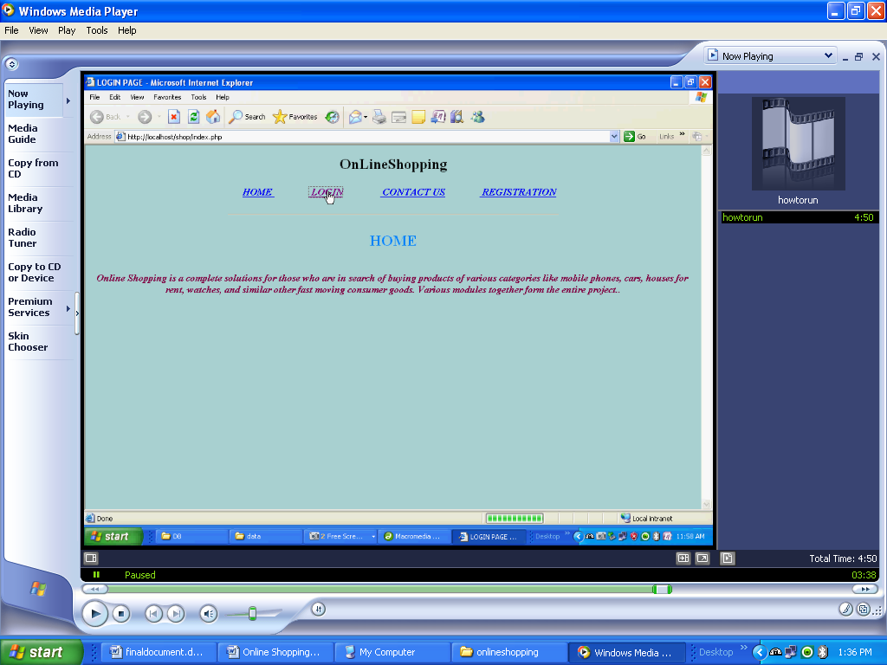

Registraction form

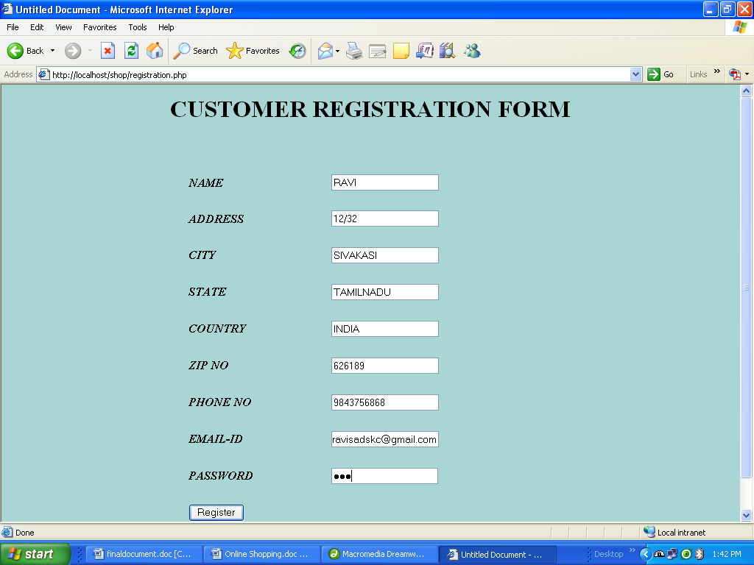

Login form

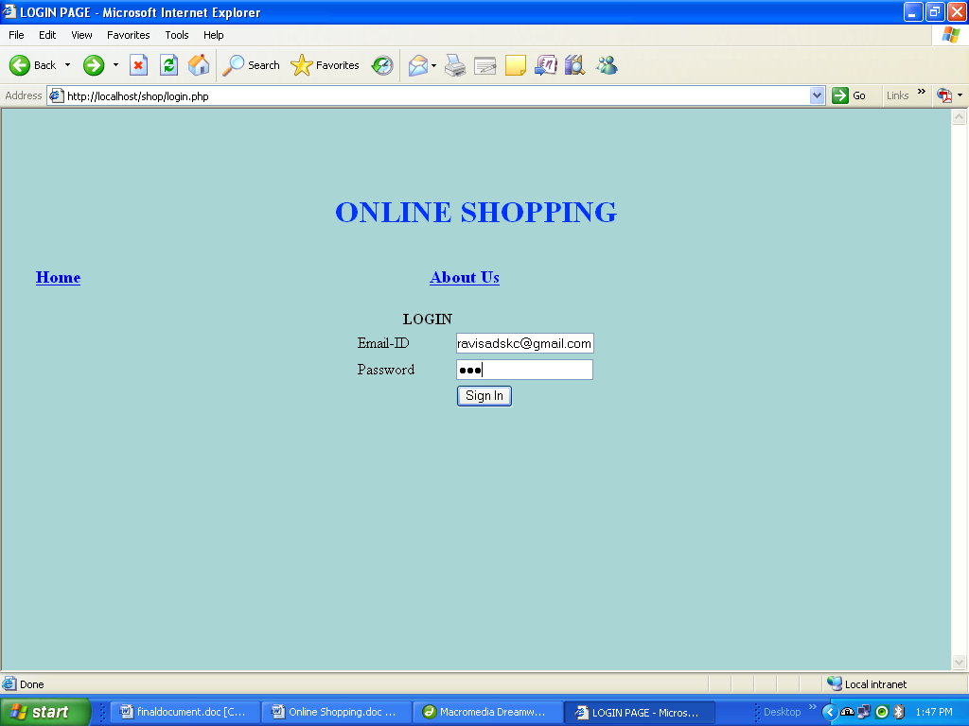

Shopping Procedure

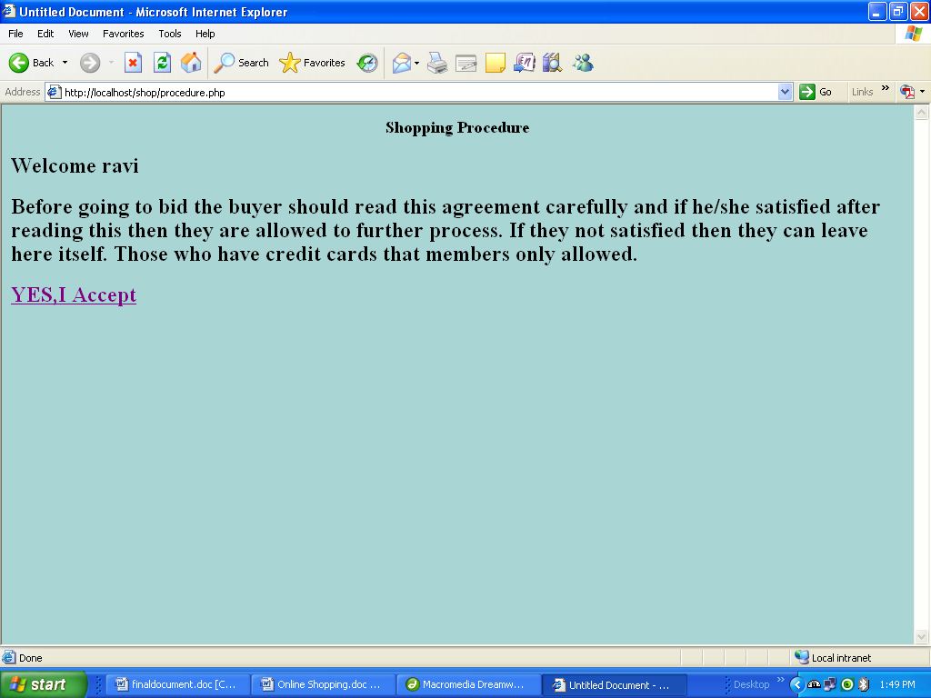

Category about product
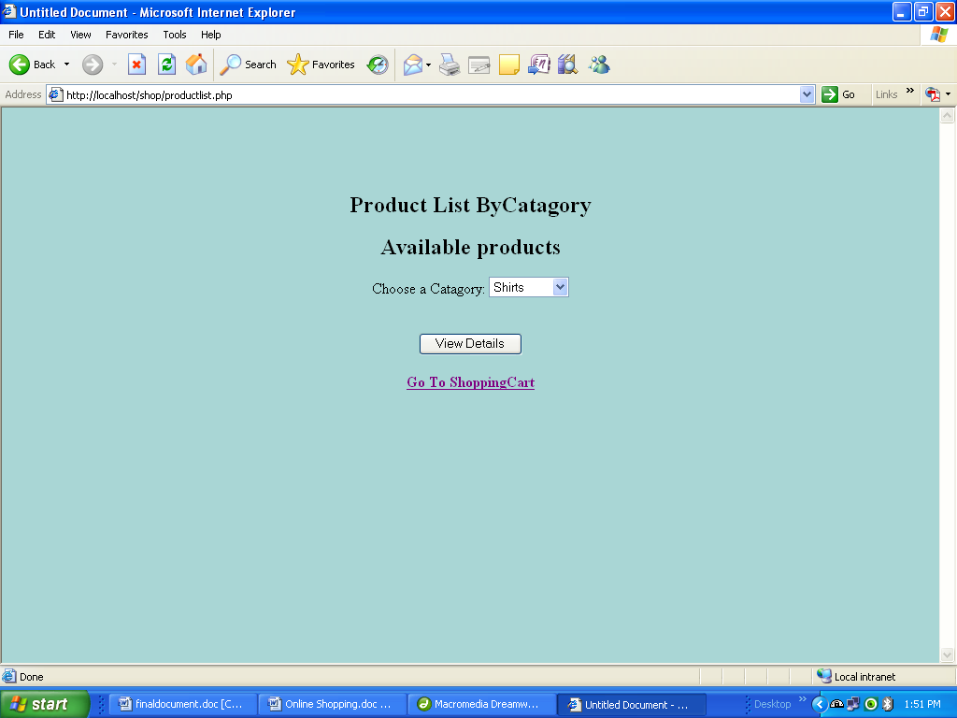

Product Details

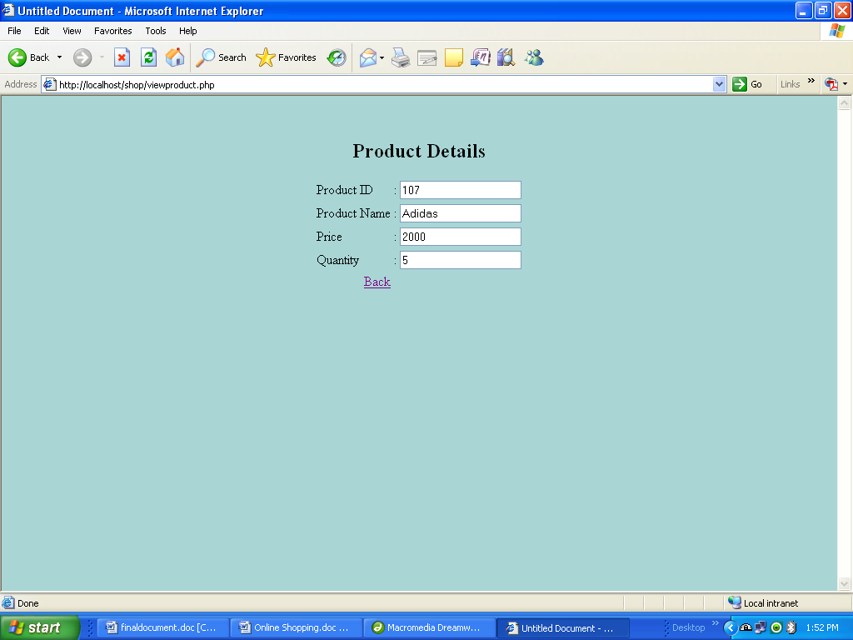

Shopping Things

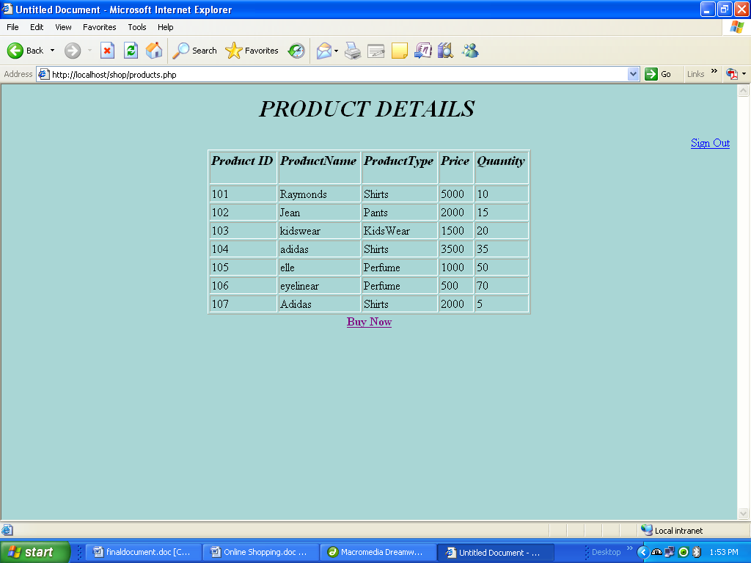

Buy things

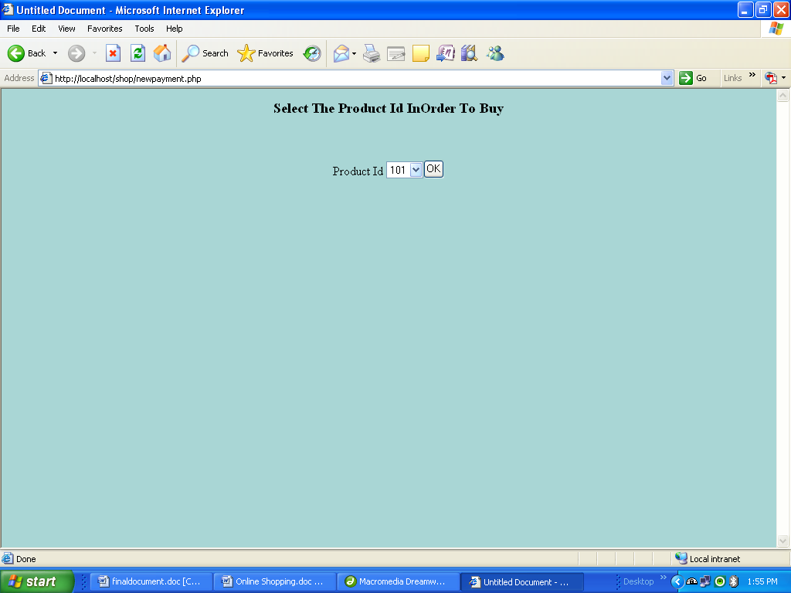

Product Goods

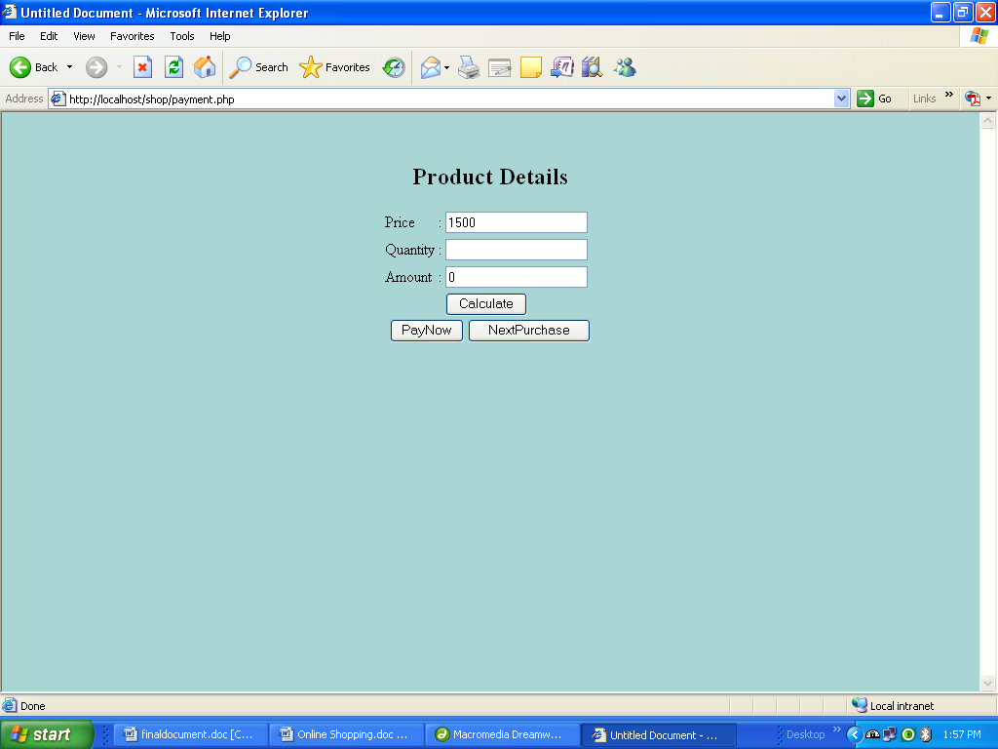

Payment Details

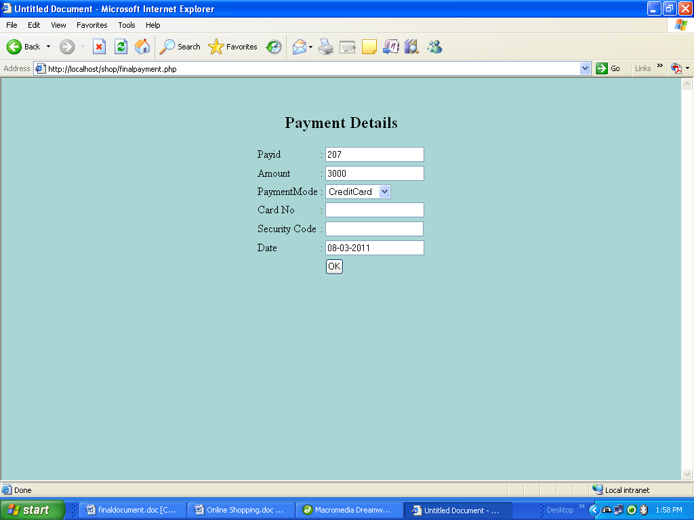

Final Payment
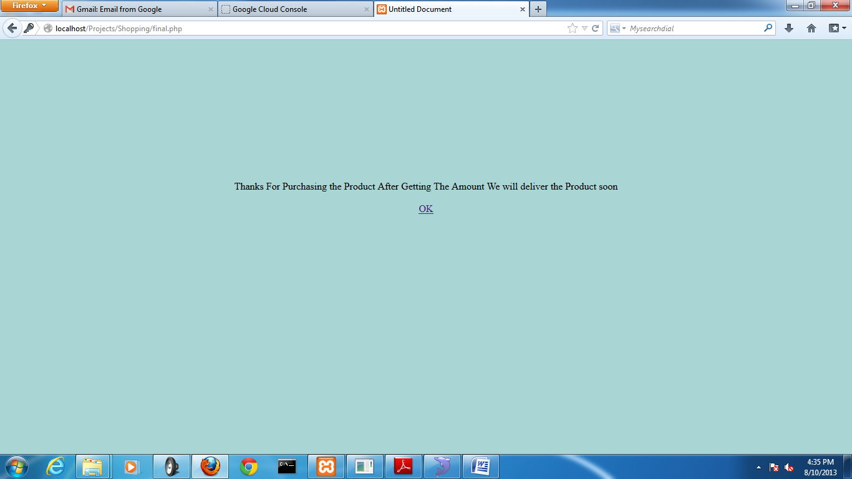

Conclusion
We have implemented the online Shopping Cart. Customer can easily bring the things and goods. We have implemented the latest technology of AJAX concept in this project.

Future Enhancement

- Statistical reports for the each Shopping.
- Reports for each things (or) goods

References

- Sams Teach Yourself PHP, MySQL™ and Apache in 24 Hours
Author: Julie C Meloni

- Upgrading PHP 5
Author: Adam Trachtenberg

